

**EE463 Project-2 Report**

Controlled Rectifiers

Hikmet Murat Çolakoğlu

Mert Elmas

Table of Contents

Introduction 1

Results 1

Part 1

Part 1

Part 1

Part 1

Part 1

Part 1

Part 1

Part 1

Part 1

[Part 1](https://docs.google.com/document/d/1BTVx0Cyo3LnY-z0z7dDpIckWM7dudHexsHnHwd_asUI/edit#heading=h.1ksv4uv)

Part 1

# Introduction

# Results

## Part 1

In order to see the correct steady state mean current value, it was necessary to pick a right interval of the graph. However it should be noted that the current waveform took some time to built up its steady state form for both topologies.

## Part 1.a

#### *Part 1.a.1*

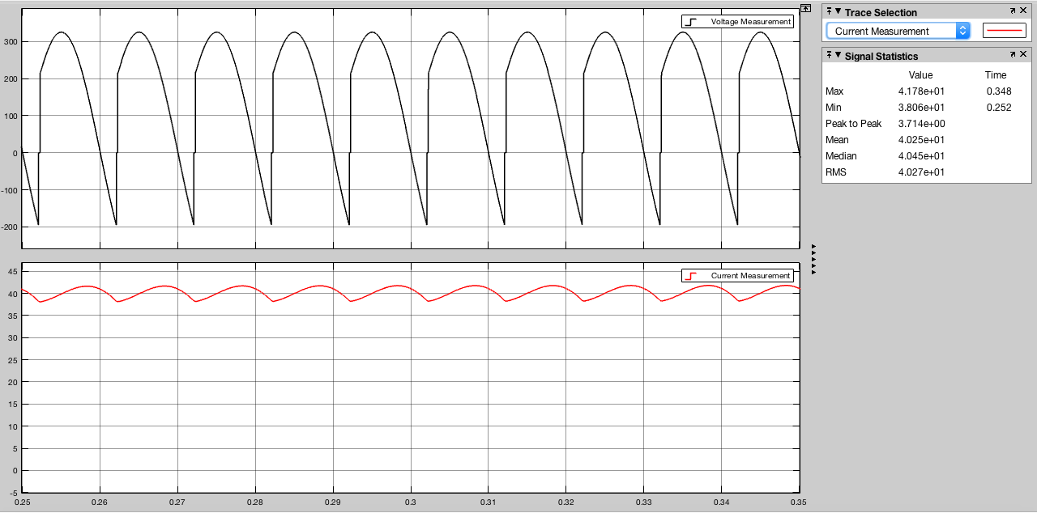

Figure:

#### 

From the figure the effect of the inductance in the circuit can be seen it the output voltage waveform as commutation.

#### *Part 1.a.2*

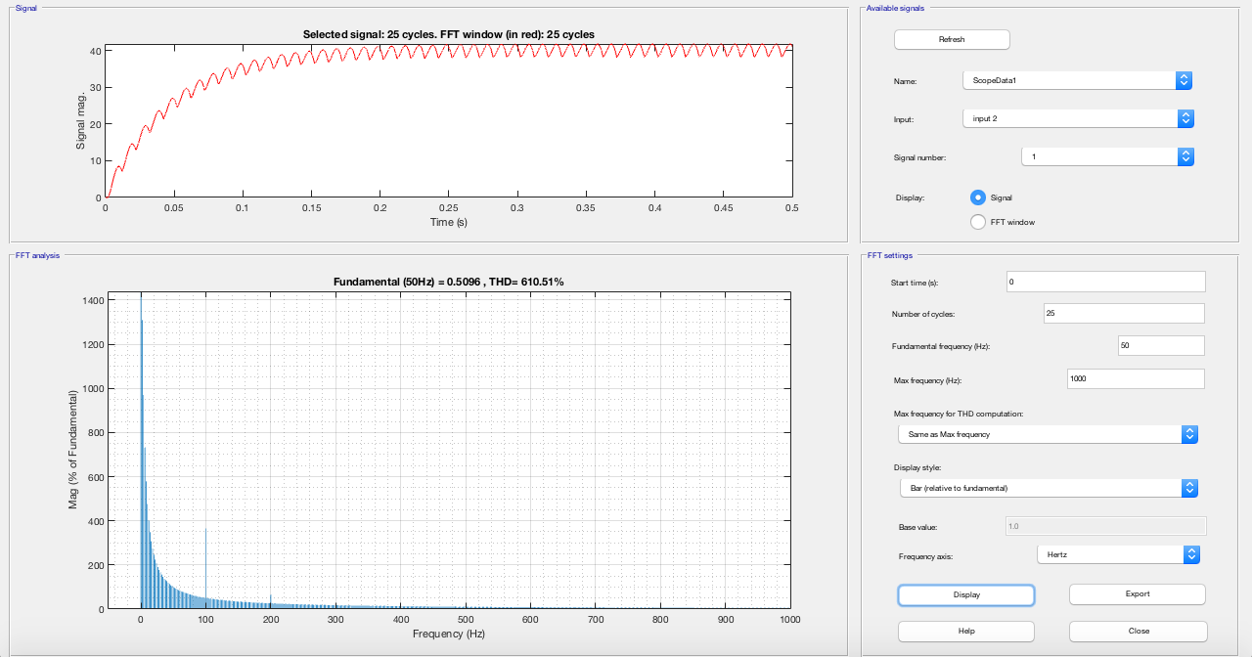

Figure:

## Part 1.b

#### *Part 1.b.1*

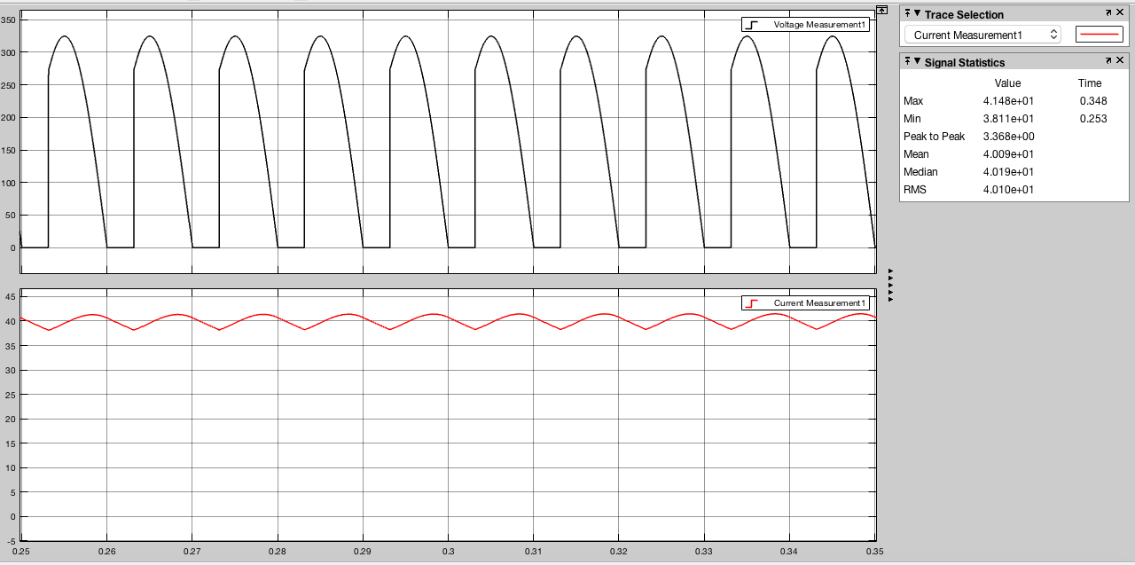

Figure:

#### 

#### 

#### *Part 1.b.2*

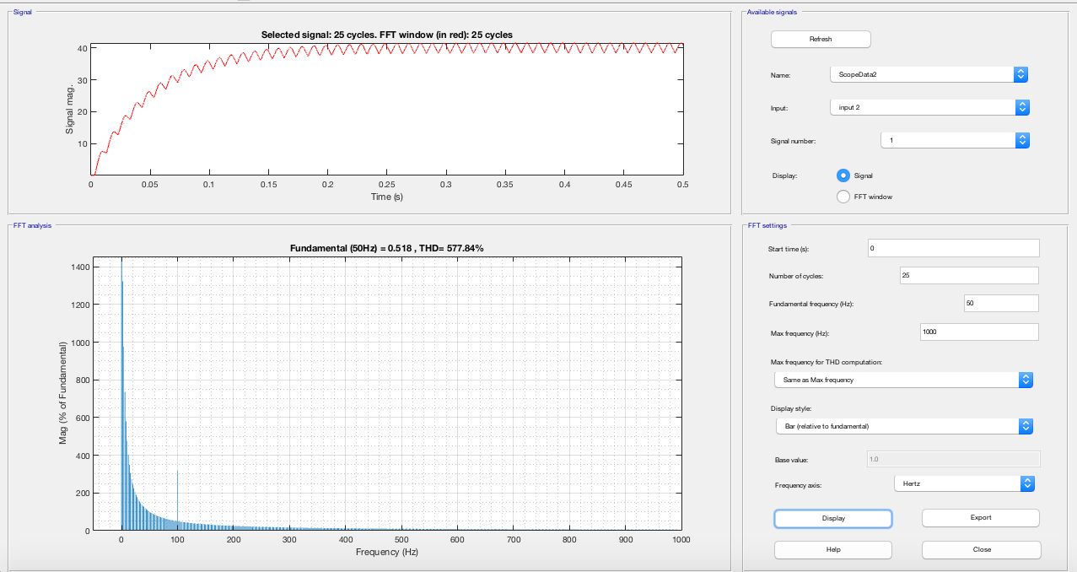

Figure:

## Part 1.c

Compare the topologies wrt to their advantages, disadvantages and their application areas. Discuss their operational similarities and differences.

Even though the Thd values and ... are found to be somewhat similar the main difference was in the output voltage waveforms where the first topology yielded a waveform with negative values the second topology yielded a non-negative valued waveform. Having an only positive voltage waveform is an advantage because of the higher mean value. This is due to the freewheeling diode which would not alove negative current through itself.

## Part 2

## Part 2.1

#### *Part 2.1.a*

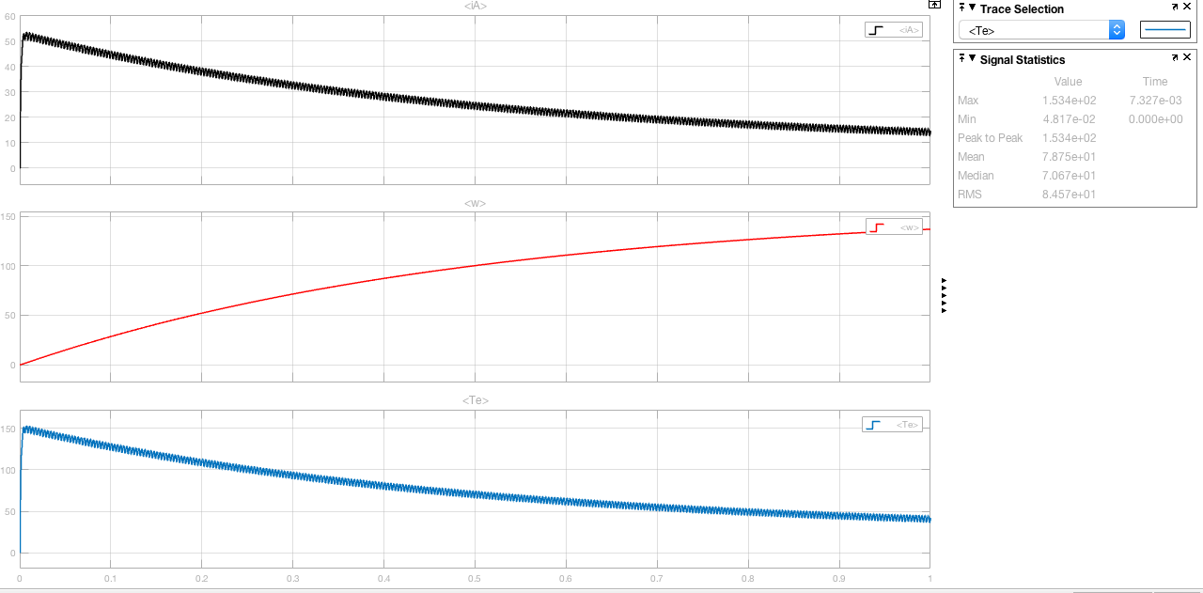

Figure:

#### *Part 2.1.b*

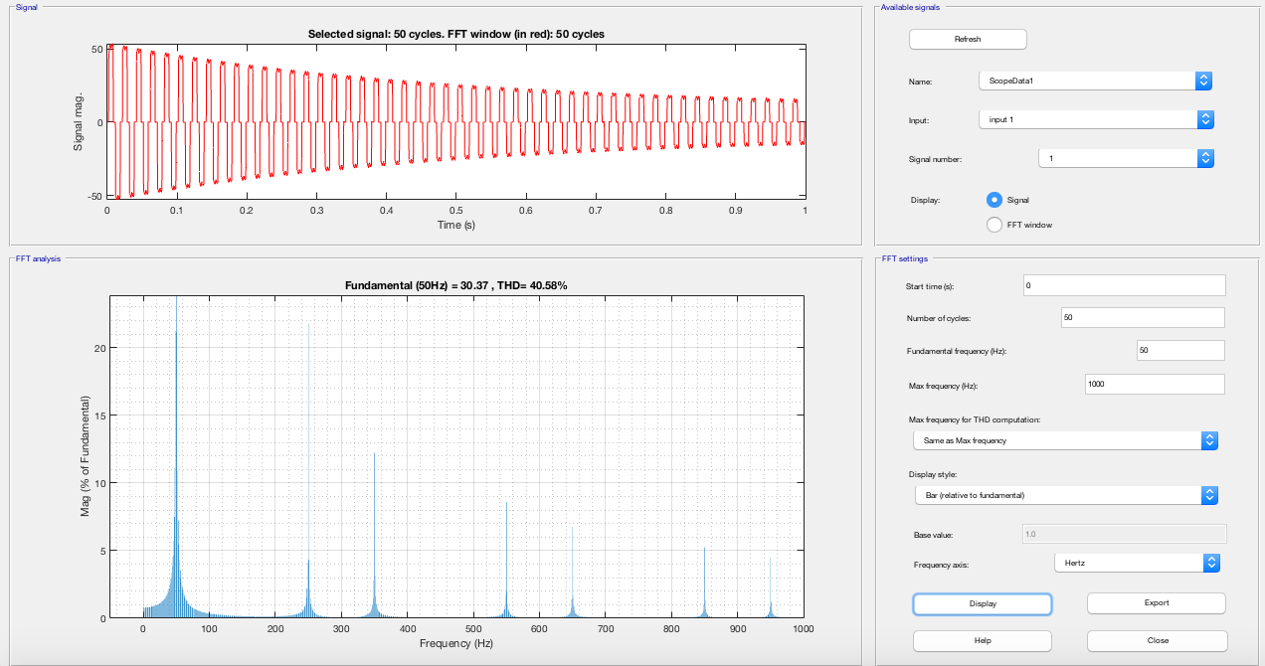

Figure:

## Part 2.2

#### *Part 2.2.a*

## Part 3

This topology is called 12 pulse rectifier topology which is also evident from the output voltage waveform.

## Part 3.1

#### 

## Part 3.2

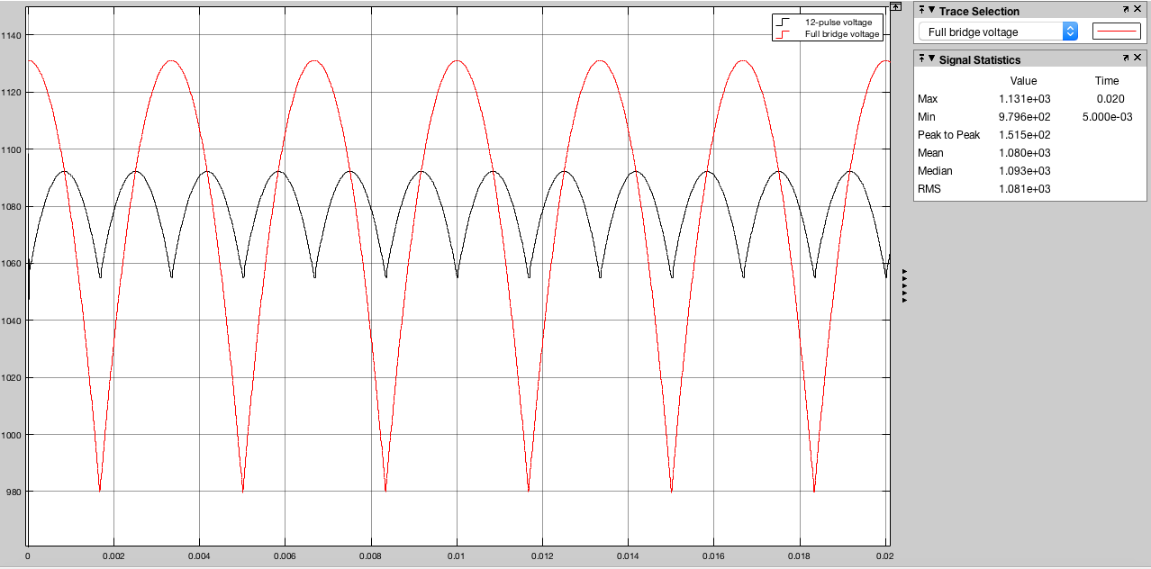

Figure:

The resulting waveforms of both of the topologies can be seen in the figure . Even though they produce voltages with the same mean value, 12-pulse rectifier topology has a less ripple in its output waveform which is something desired.